**EC2 Instance Storage**

**What’s an EBS Volume?**

EBS Volume is a network drive for EC2 instances that persists data and can only be attached to one instance at a time. It is bound to a specific availability zone and has a 30 GB free tier.

**EBS Volume:**

* Network drive with latency
* Detachable and attachable quickly
* Locked to an AZ
* Must be snapped to move across AZs
* Provisioned capacity (size and IOPS)
* Billed for all provisioned capacity
* Capacity can be increased over time

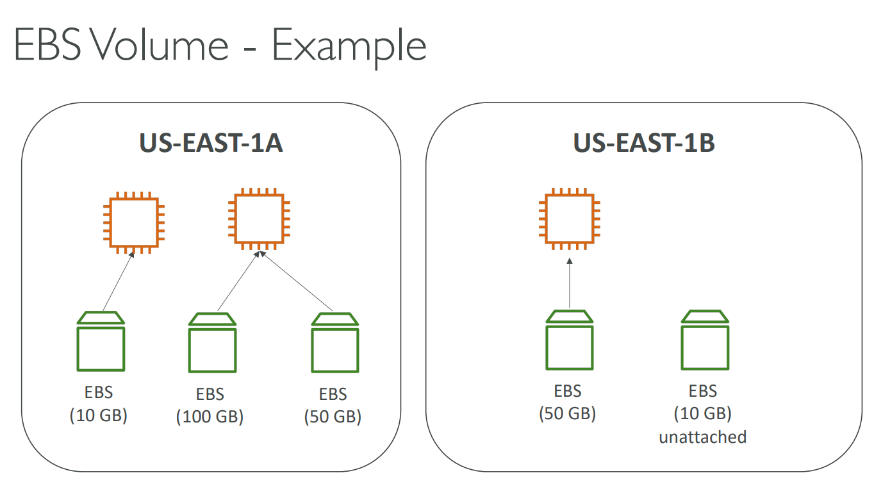

**EBS Delete on Termination attribute**

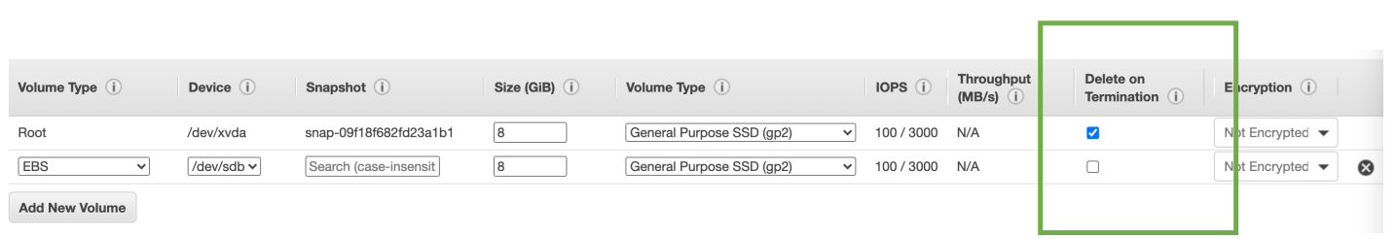

* By default, the root EBS volume deletes when the instance terminates (enabled). Other volumes are not deleted (disabled).
* You can adjust this behaviour using the AWS Console or CLI.
* Use case: If you want to keep the root volume when an instance is terminated, you can modify this setting.

**EBS Snapshots**EBS snapshots are point-in-time backups of EBS volumes. You don't need to detach a volume to take a snapshot, but it's recommended.   
You can copy snapshots across Availability Zones or Regions.

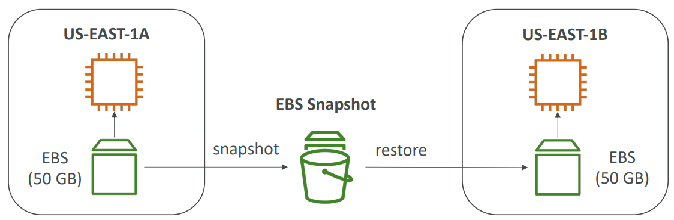

**EBS Snapshots Features:  
  
EBS Snapshot Archive:** Stores snapshots for 75% less cost, but takes 24-72 hours to restore.  
**Recycle Bin:** Retains deleted snapshots for 1 day to 1 year, so you can recover them accidentally.  
**Fast Snapshot Restore (FSR):** Forces full initialization of a snapshot to eliminate latency on first use, but is more expensive.

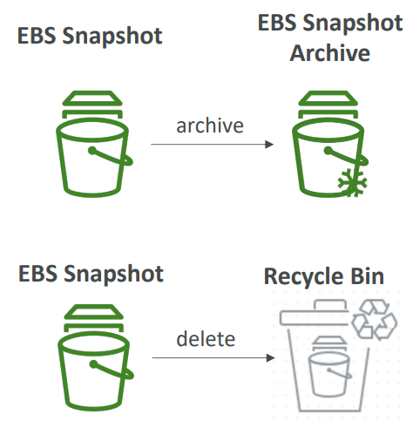

**AMI (Amazon Machine Image) Overview**

* AMI is a customized EC2 instance with pre-packaged software, configuration, OS, and monitoring.
* Faster boot and setup due to pre-packaged software.
* Region-specific (can be copied to other regions).
* Launch EC2 instances from:
  + Public AMI (AWS-provided).
  + Your own AMI (self-maintained by yourself).
  + AWS Marketplace AMI (by others, possibly for sale).

**AMI Process from EC2 Instance**

1. Start an EC2 instance and customize it to your needs.
2. Stop the instance to ensure data integrity.
3. Build an AMI (Amazon Machine Image), which also creates EBS snapshots of the instance.
4. You can now launch new instances from the created AMI with the same configuration as the original one.

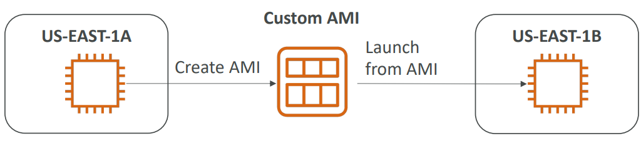

**EC2 Instance Store:**

* Hardware disk with high I/O performance
* Ephemeral storage - lost when instance is stopped
* Good for temporary data
* Risk of data loss if hardware fails
* Backups and replication are your responsibility

**EBS Volume Types**

**EBS Volumes come in 6 types:**

* **General purpose SSD (gp2/gp3):** best for most workloads, balanced price and performance.
* **High performance SSD (io1/io2):** best for mission-critical workloads
* **Low cost HDD (st1):** best for frequently accessed workloads
* **Lowest cost HDD (sc1):** best for less frequently accessed workloads
* EBS Volumes are Characterized by Size, Throughput, IOPS.
* Only gp2/gp3 and io1/io2 can be used as boot volumes

**EBS Volume Types Use cases**

**General Purpose SSD**

General Purpose SSD (gp2 and gp3) EBS volumes are cost-effective storage with low latency, making them ideal for system boot volumes, virtual desktops, and development and test environments. They come in sizes from 1 GiB to 16 TiB.

* gp3 volumes have a baseline of 3,000 IOPS and throughput of 125 MiB/s, and can be scaled up to 16,000 IOPS and 1,000 MiB/s independently.
* gp2 volumes, on the other hand, have a linked IOPS and size relationship, with a maximum of 16,000 IOPS at 5,334 GB.

**Provisioned IOPS (PIOPS) SSD**

* Ideal for critical business apps and >16,000 IOPS needs.
* Excellent for I/O-sensitive databases.
* io1/io2 (4 GiB - 16 TiB):
* Max PIOPS: 64,000 (Nitro) or 32,000 (others).
* PIOPS can be increased independently.
* io2 has more durability and more IOPS per GiB (same price as io1).
* io2 Block Express (4 GiB - 64 TiB):
* Sub-millisecond latency.
* Max PIOPS: 256,000 with 1,000:1 IOPS:GiB ratio.
* Supports EBS Multi-attach.

**HDD (Hard Disk Drives)**

* Cannot be a boot volume
* Size: 125 GiB to 16 TiB

|  |  |  |  |
| --- | --- | --- | --- |
| Type | Use cases | Max throughput | Max IOPS |
| Throughput Optimized HDD (st1) | Big data, data warehouses, log processing | 500 MiB/s | 500 |
| Cold HDD (sc1) | Infrequently accessed data, lowest cost | 250 MiB/s | 250 |

**EBS –Volume Types Summary**

|  | [**General Purpose SSD volumes**](https://docs.aws.amazon.com/AWSEC2/latest/UserGuide/general-purpose.html) | | [**Provisioned IOPS SSD volumes**](https://docs.aws.amazon.com/AWSEC2/latest/UserGuide/provisioned-iops.html) | | |
| --- | --- | --- | --- | --- | --- |
| **Volume type** | gp3 | gp2 | io2 Block Express ‡ | io2 | io1 |
| **Durability** | 99.8% - 99.9% | | 99.999% | | 99.8% - 99.9% |
| **Use cases** | Transactional workloads, Virtual desktops, Medium-sized, single-instance databases, Low-latency interactive applications, Boot volumes, Development and test environments | | Workloads that require:  Sub-millisecond latency, Sustained IOPS performance, More than 64,000 IOPS or 1,000 MiB/s of throughput | Workloads that require sustained IOPS performance or more than 16,000 IOPS, I/O-intensive database workloads | |
| **Volume size** | 1 GiB - 16 TiB | | 4 GiB - 64 TiB | 4 GiB - 16 TiB | |
| **Max IOPS per volume** (16 KiB I/O) | 16,000 | | 256,000 | 64,000 † | |
| **Max throughput per volume** | 1,000 MiB/s | 250 MiB/s * | 4,000 MiB/s | 1,000 MiB/s † | |
| **Amazon EBS Multi-attach** | Not supported | | Supported | | |
| **Boot volume** | Supported | | | | |

**Summary:**

* gp3 and gp2 are general-purpose SSD volume types. gp3 offers better performance and lower latency than gp2, but it is more expensive.
* io2 is a provisioned IOPS SSD volume type. It is ideal for workloads that require sustained IOPS performance.
* Block Express is a new EBS volume type that is designed for I/O-intensive database workloads. It offers the highest performance and lowest latency of all EBS volume types.

**EBS Multi-Attach - io1/io2 family**

EBS Multi-Attach for io1/io2 volumes allows you to attach the same EBS volume to multiple EC2 instances in the same AZ, with full read and write permissions for each instance. This can be used to achieve higher application availability in clustered Linux applications, but you must use a cluster-aware file system.

**EFS - Elastic File System**

EFS is a managed NFS file system that is highly available, scalable, and expensive. It can be mounted on many EC2 instances in multi-AZ and is compatible with Linux-based AMIs. EFS uses NFSv4.1 protocol and security groups to control access. It also encrypts data at rest using KMS. EFS scales automatically and is pay-per-use, so there is no need for capacity planning.

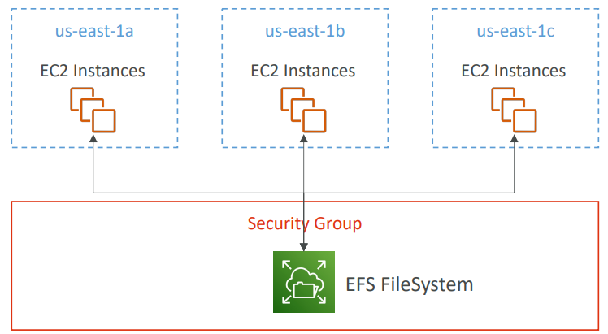

**EFS Performance & Storage Classes**

EFS is a high-performance, scalable network file system that can handle thousands of concurrent clients and petabytes of data. It offers three throughput modes: Bursting, Provisioned, and Elastic. You can choose the performance mode that best meets your needs, depending on whether you need latency-sensitive or throughput-optimized performance.

**Important:**

* The performance mode is set at EFS creation time and cannot be changed.
* The Bursting throughput mode is best suited for unpredictable workloads.
* The Provisioned throughput mode is best suited for workloads with consistent throughput requirements.
* The Elastic throughput mode is best suited for workloads with variable throughput requirements.

**EFS Storage Classes**

|  |  |  |
| --- | --- | --- |
| **Storage Class** | **Use Cases** | **Availability and Durability** |
| Standard | Frequently accessed files | Multi-AZ, great for production |
| Infrequent Access (EFS-IA) | Files that are infrequently accessed | Cost to retrieve files, lower price to store |
| One Zone | Development, backup | One AZ, compatible with IA (EFS One Zone-IA), backup enabled by default |

**EBS vs EFS**

|  |  |  |
| --- | --- | --- |
| **Feature** | **EBS** | **EFS** |
| Number of Instances | 1 (except multi-attach io1/io2) | Hundreds |
| Availability Zone | Locked | Can be mounted across AZs |
| IOPS | Increases with disk size for gp2, can be increased independently for io1 | Not dependent on disk size |
| Migration across AZs | Snapshot and restore | Not required |
| Backups | Use I/O, should not be run during high traffic | Do not use I/O |
| Root volume termination | Terminated by default | Not terminated by default |
| Use Cases | Persistent storage for a single instance, databases, boot volumes | Shared file storage for multiple instances, website files, development environments |
| Price | Lower | Higher |
| Cost Savings | EBS snapshots | EFS-IA |